Chapter 30 - South Carolina

The Chapter 30 (SC) 2012 agenda was introduced to the chapter for changes and/or approval for the entire year. We went to The Red Bone Alley Restaurant in Florence, South Carolina for our March meeting. We’re going to be visiting the Special Forces Museum in Fayetteville, NC and have lunch with members of Chapter 5 of Fayetteville, N.C., at the Golden Corral on Ramsey Street, on 14 April 2012 @ High Noon.

If you love dogs, you'll love War Dogs

Your invitation to get involved and be a part of:
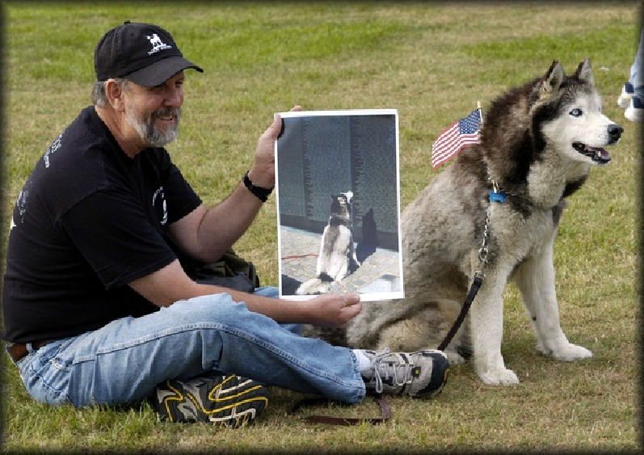

VETERANS WAR DOG MONUMENT
Honoring Military Working Dog Teams, Past to Present

LOCATION: VETERANS MEMORIAL PARK,
COLUMBIA, SC

PROJECT COST SUMMARY:
PHASE 1: Granite Base and Bronze Handler and German Shepherd
GRANITE BASE: $49,500.00 with $25,000.00 needed to start work.
Quote includes production, shipment, and placement. Time frame for granite ready to ship - approx. 4 months.

BRONZE HANDLER & GS DOG: $70,000.00 with $5,000.00 needed to start.
Time frame for artist Renee Bemis is 6 - 9 months to produce (10%) larger than life Handler and German Shepherd.

The foundry's production time for bronze work is 6 -9 months.

So with production time possibly up to 1-1/2 years for the handler and dog, will allow time for fundraising for the Bronze.

Total Phase 1: $120,000.00
PHASE 2: 3 BRONZE DOGS - $20,000.00 each (Doberman, Lab, & Belgian Mai) Total Phase 2: $60,000.00

TOTAL ESTIMATE Phase 1 & 2: $180,000.00 - $200,000.00
For further information, please contact Johnny Mayo at 803-767-6756

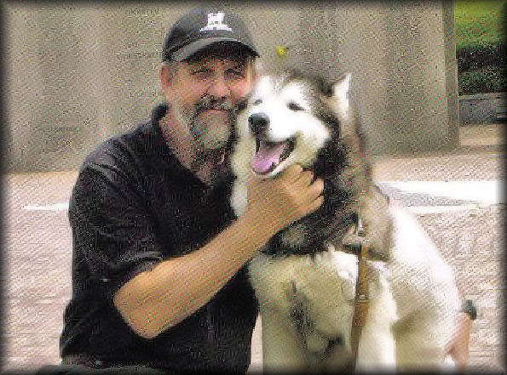
Johnny Mayo Appeared at a Charleston, SC Dog Show

One organization that is working toward a unique goal is Buck’s Heroes, which is run by Johnny Mayo, a former scout dog handler who served in the Vietnam War. The original idea behind Buck’s Heroes was to educate the public about the role of working dogs in the U.S. military and to honor those dogs for their service and sacrifices. What started as a single presentation for a patriotic event some ten years ago has become a full-time nationwide initiative. Currently, Mayo is working to raise funds for a memorial to the military working dogs to be erected in Veterans Memorial Park in Columbia. The goal is to raise $200,000 for the memorial, he said.

Mayo has been invited to appearances and engagements all over the country and has been featured on Oliver North’s television show “War Stories,” among other events.

“I thought this was going to be a one time, one weekend deal; it’s now going on ten years,” he said.

For more information people can visit Mayo’s website at www.bucksheroes.com

Original article:
http://www.journalscene.com/news/Charleston-Dog-Show-brings-in-more-than-1000-competitors

From: The State, Monday, 19 Dec 2011
Dog can be a vet’s best friend - Help with PTSD

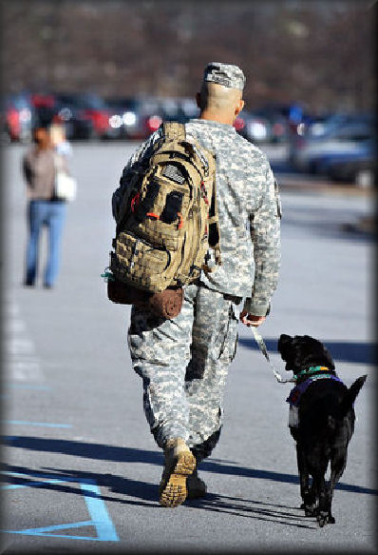
"Columbia's 1st Sgt. Will Roberts, a U.S. Army paratrooper, has been deployed into combat seven times with the elite 173rd Airborne Brigade Combat Team. Kosovo, Bosnia. two deployments to Iraq -- three to Afghanistan."

He is 45 years old and awaiting retirement from the Army. This Airborne Ranger was traumatized by a roadside bomb in Afghanistan and is being treated for PTSD at the Warrior Transition Unit at Fort Jackson. His helper is a 55 pound black Labrador Retriever named R.C. She was given to him by the Palmetto Animal Assisted Life Services (PAALS). Jennifer Rogers operates PAALS out of her Spring Valley home in Columbia with her husband Charles. 1SG Rogers sometimes volunteers at the PAALS location.
First Sgt. Will Roberts fought as a paratrooper in the Gulf War, Bosnia, Kosovo, Iraq and Afghanistan. He now is struggling with PTSD and uses a service dog, R.C., to help him go outside and be around other people.

- Kim Kim Foster-Tobin /kkfoster@thestate.com

Other information in the article mentions a psychologist at Moncrief Army Community Hospital named Allison Thirkield. Each PAALS dog costs about $25,000 to purchase and train.

Director, Warrior Transition Unit (803) 751-2628
Warrior Transition Unit (803) 751-2517

Original article:
http://www.thestate.com/2011/12/19/2085030/dogs-can-be-vets-best-friends.html

Our first 173d Transfer to Chapter 30.

We extend a warm welcome to Kaare Patterson (A/2/503rd), who served with the 173rd. He’s originally from SanLuis Obispo, CA. Welcome aboard, Brother!

New Associate Member

We have another New Associate Member - George Gorsuch . George (of Muncie, Indiana) is a friend of Barb and Top Dresser and was voted 100% into Chapter 30.

